**Host A Static website on Apache / Nginx server**

Step 1: For An ec2 instance this is the following configuration

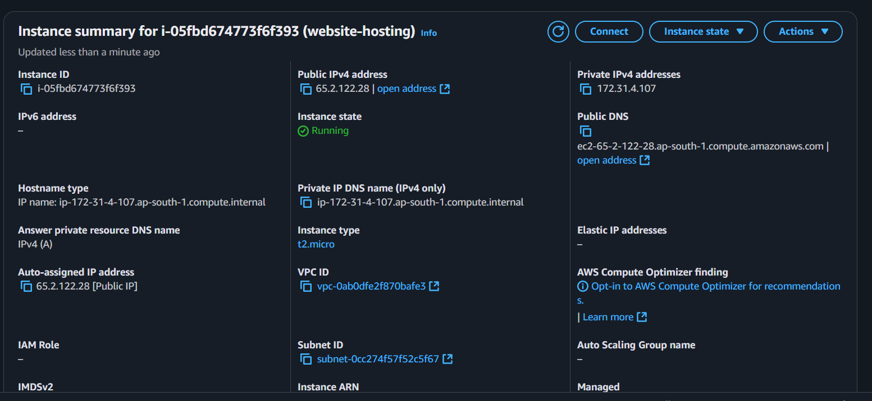

2. Security Group Configuration

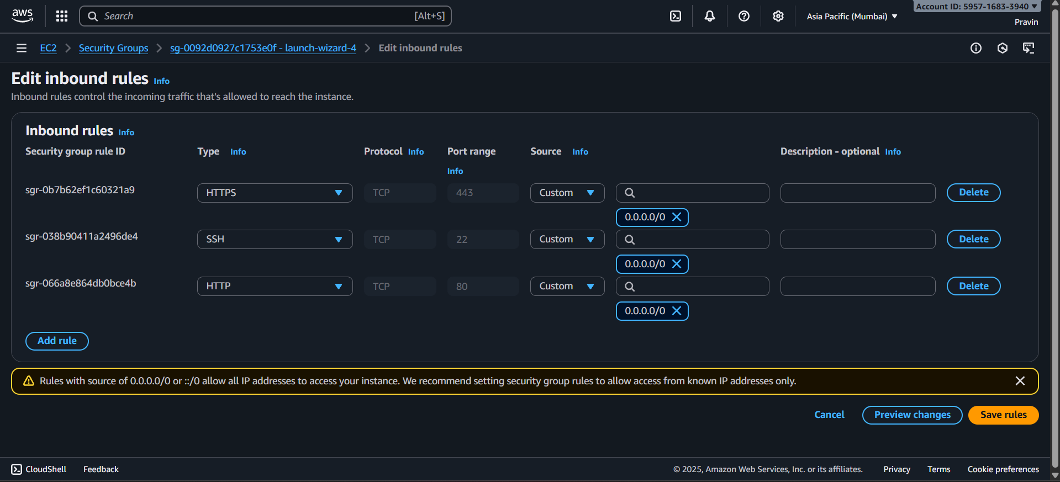

Step 3: Connect the Ec2 instance using SSh:

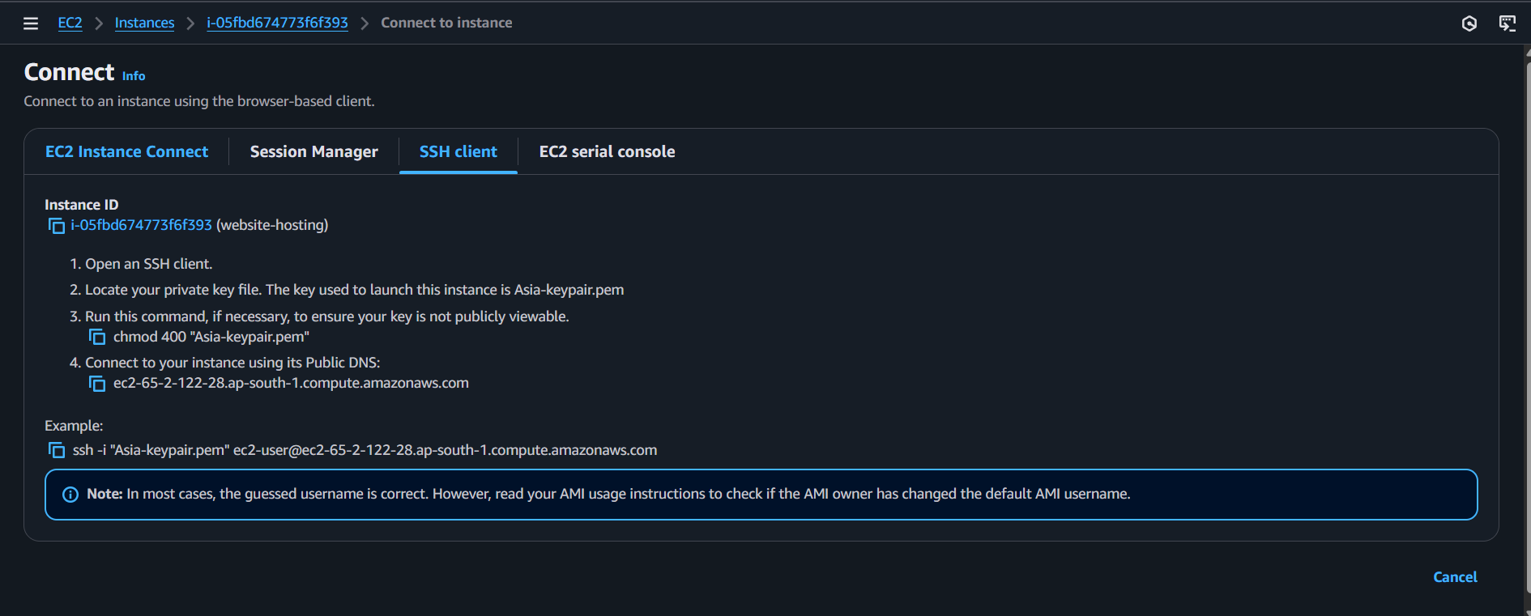

Step 4: Setup the Web server for webhosting

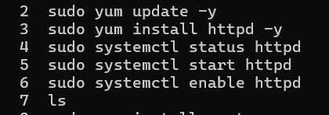

Step 5: In the folder of /var/www/html deploy your code

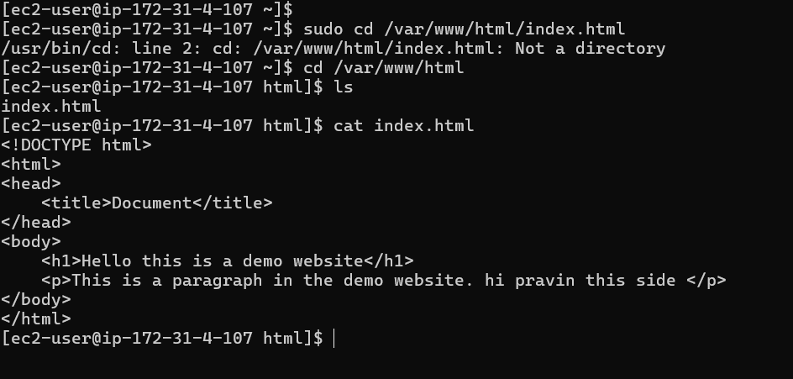

Paste the public link into your browser

Demo Website Link:

<http://65.2.122.28/>

